**Assignment 1**

**WAD**

**Section E1**

**Question 1: Make the following layout using html and css (5 Marks).**

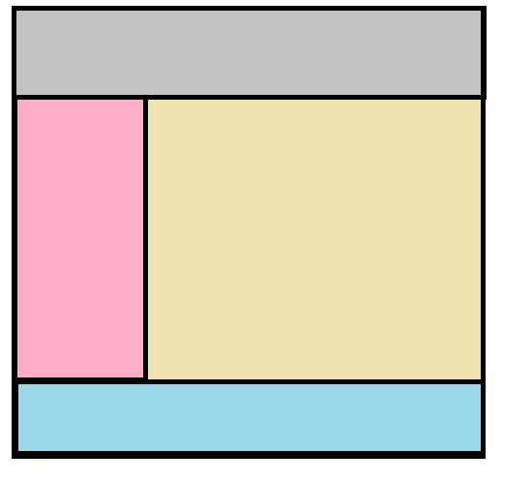

**Question 2: Make the following layout using html and css (5 Marks).**

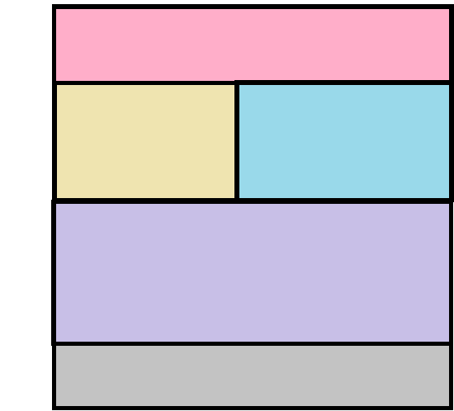

**Question 3: Make the following layout using html and css (5 Marks).**

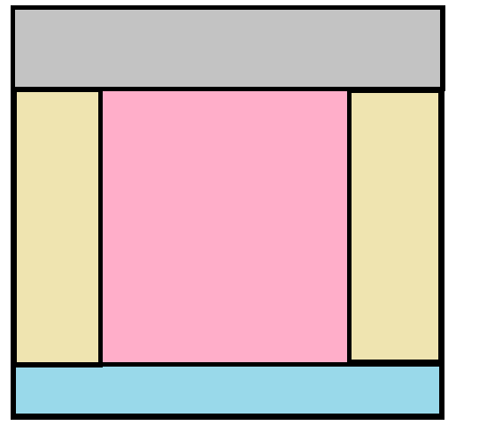

**Question 4: Make the following layout using html and css (5 Marks).**

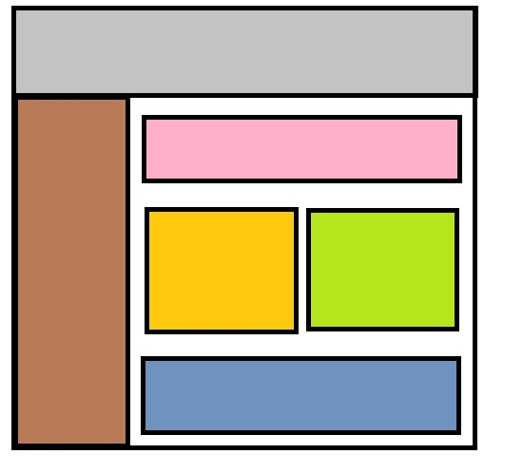

**Question 5: Make the following layout using html and css (10 Marks).**

